Project Design Phase-II
Technology Stack (Architecture & Stack)

Date | 8 July 2026
Team ID
Project Name | Food Ordering Behaviour and Customer Trends
Maximum Marks | 4 Marks

Technical Architecture:
The Deliverable shall include the architectural diagram as below and the information as per the table1 & table 2
Food Ordering Behaviour and Customer Trends – Architecture Flow
Guidelines:
Include all the processes (As an application logic / Technology Block)
Provide infrastructural demarcation (Local / Cloud)
Indicate external interfaces (third party API’s etc.)
Indicate Data Storage components / services
Indicate interface to machine learning models (if applicable)
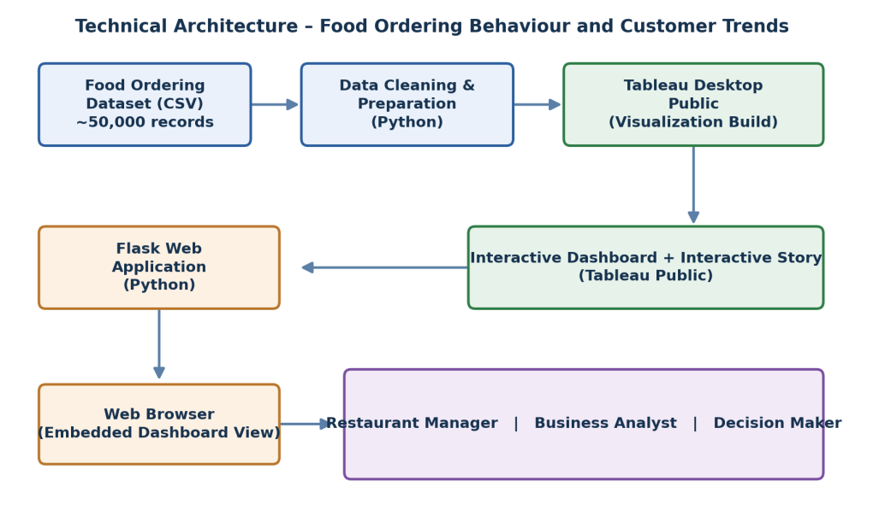

Table-1 : Components & Technologies:
S.No | Component | Description | Technology
 | User Interface | How users interact with the analytics application, viewing dashboards through a web browser  Web-based Dashboard embedded via the Flask application | HTML5, CSS3, JavaScript
 | Application Logic-1 | Handles HTTP routing, renders web pages, and embeds the Tableau dashboard within the Flask application | Python, Flask
 | Application Logic-2 | Cleans and prepares the raw CSV dataset prior to visualization (handling missing values, formatting fields, etc.) | Python
 | Application Logic-3 | Integrates the Tableau dashboard and story into the web application using an embedded view | Tableau Public (Embedded View), HTML5
 | Database | This project does not use a traditional database; data is sourced directly from a CSV file | Not Applicable for this project
 | Cloud Database | Not Applicable for this project | Not Applicable for this project
 | File Storage | Storage of the raw and cleaned food ordering dataset used to build the dashboard | Local File System (CSV)
 | External API-1 | Not Applicable for this project | Not Applicable for this project
 | External API-2 | Not Applicable for this project | Not Applicable for this project
 | Machine Learning Model | Not Applicable for this project | Not Applicable for this project
 | Infrastructure (Server / Cloud) | Application Deployment on Local System  Local Server Configuration: Flask development server run on Windows/macOS with Python 3  Version Control: Source code maintained using Git and hosted on GitHub (no cloud server used) | Local Machine, Tableau Public (Dashboard Hosting)

Table-2: Application Characteristics:
S.No | Characteristics | Description | Technology
 | Open-Source Frameworks | Open-source frameworks and libraries used to build the application | Flask (Python), HTML5, CSS3, JavaScript
 | Security Implementations | Public Tableau dashboard with controlled repository access through GitHub; no sensitive or personal data is exposed in the published dashboard | GitHub repository access control
 | Scalable Architecture | New dashboards, datasets, and visualizations can be added without changing the overall application architecture | Modular Flask application structure
 | Availability | Dashboard is accessible through Tableau Public and the Flask web application without dependency on a dedicated hosting server | Tableau Public hosting
 | Performance | Optimized Tableau visualizations and efficient dashboard loading through pre-aggregated views and filtered data extracts | Tableau Public rendering optimization

References:
https://c4model.com/
https://developer.ibm.com/patterns/online-order-processing-system-during-pandemic/
https://www.ibm.com/cloud/architecture
https://aws.amazon.com/architecture
https://medium.com/the-internal-startup/how-to-draw-useful-technical-architecture-diagrams-2d20c9fda90d

